**Assignment 3.2**

We have a dataset of sales of different TV sets across different locations. Records look like: Samsung|Optima|14|Madhya Pradesh|132401|14200 The fields are arranged like: Company Name|Product Name|Size in inches|State|Pin Code|Price There are some invalid records which contain 'NA' in either Company Name or Product Name. 1. Write a Map Reduce program to filter out the invalid records. Map only job will fit for this context.

**Mapper class:**

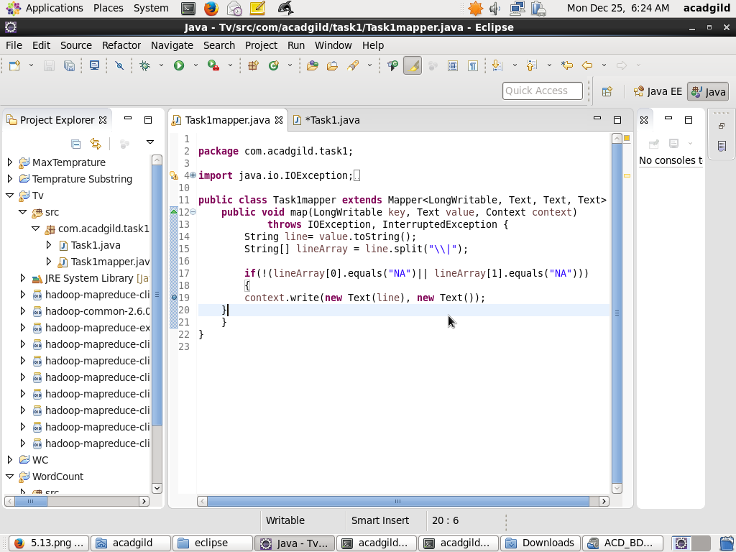

**Driver: Task1**

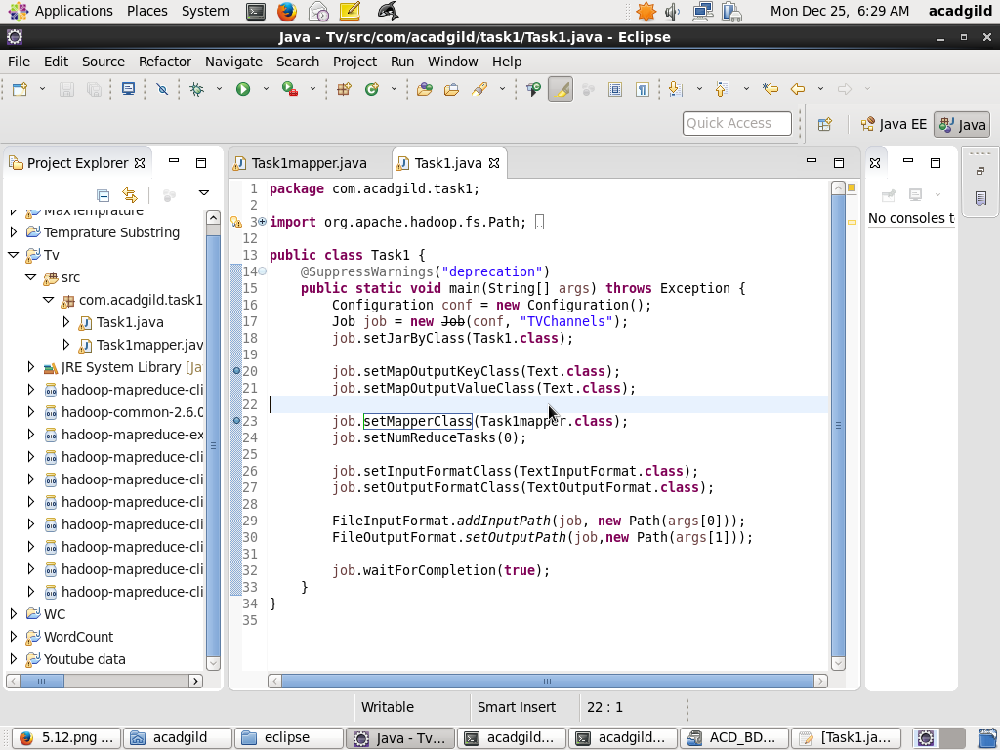

**Execution of the mapreduce program**:

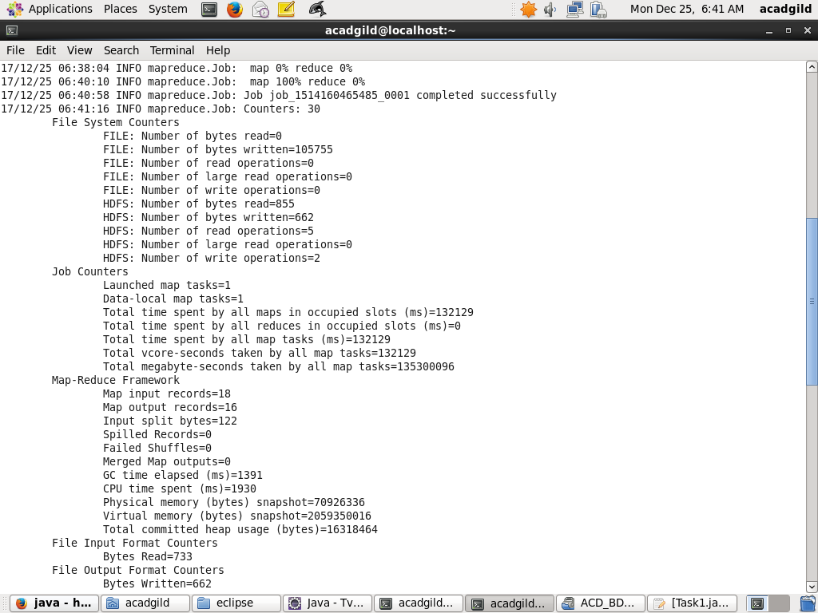

**Results to filter out the invalid records**

